****Twitionary****

****AI-Driven****

****Crowd-Sourcing Platform****

**Prepared for:**  
**Irfan Syed**

Version: 1.2

Dated: 21/09/2020

Contents

About Twitionary AI-Driven Platform 2

Source of Data collection 2

Features 2

Features Coming soon 2

How it works 2

Purpose of mobiles twitionary platform 3

Status of application 4

What are the next steps? 4

# About Twitionary AI-Driven Platform

Twitionary is an artificial intelligence-powered crowdsourcing platform to collect & analyze data from twitter on provided keywords Twitionary analyze collected data and perform sentiment analysis

# Source of Data collection

* Twitter

# Features

* Addition/deletion of keywords for data collection
* Archived data from time of deployment
* Scape 150,000 tweets per day
* Perfume sentiment analysis on every record
* Statically/Graphically view of performed analysis,
* p[remium reports](https://socialbearing.com/twitter-reports) for any historical tweets

# Features Coming soon

* Twitter search, insights & analytics
* See who's tweeting about you or your brand
* Fullscreen tweets and auto refresh features
* Sort tweets by reach, engagements, language & more
* View top influencers, mentions & hashtags
* Search user timelines, followers & friends
* Tweet photo walls
* Tweet snapshot
* Thread initation
* Filter your home timeline, mentions & engagements
* Geolocated tweets & map
* Export Twitter charts and graphs
* Customisable analytics dashboard
* Today Top Trend sentiment analysis

# How it works

Based on provided data dictionary (user can update dictionary) twitionary Scrape Data from different twitter, it stored the scraped data in Database

Based on scrape data Twitionary ML module perform sentiment analysis, the platform is hosted on Google cloud server <http://34.68.136.134/blog/>

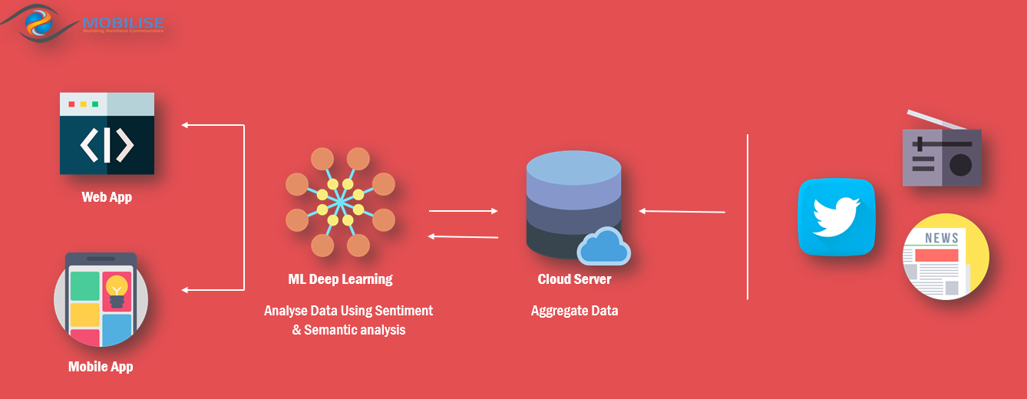

# Purpose of mobiles twitionary platform

* Reduce manual work
* Improve organization media campaign for public awareness
* Real-time data availability
* help in decision making

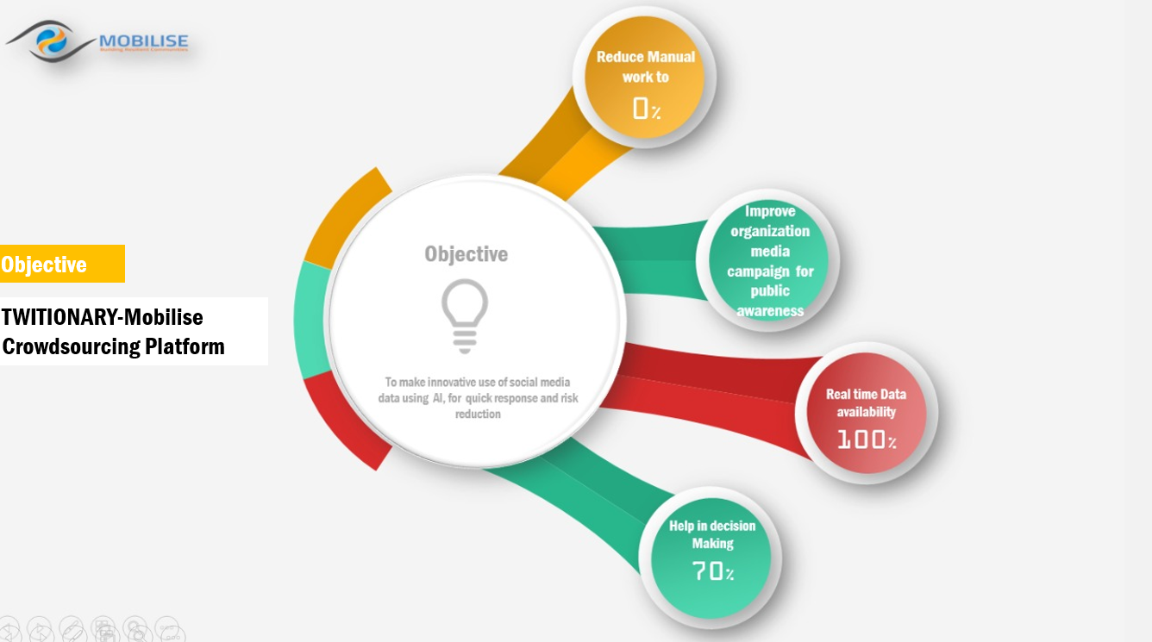

# Status of application

The web application is fully functionally hosted on Google cloud platform <http://34.68.136.134/blog/>

# What are the next steps?

* Add Statically/Graphically analysis based on scape data
* Adding Coming soon featuers mentioned above